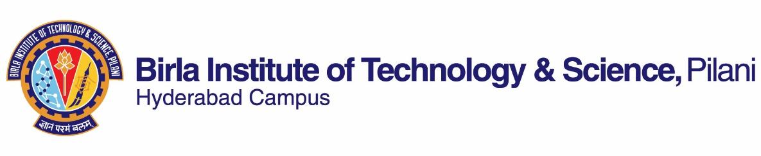

**SECOND SEMESTER 2021-2022**

# Course Handout Part II

Date: 15-01-2022

In addition to part-I (General Handout for all courses appended to the time table) this portion gives further specific details regarding the course.

***Course No.* : BIOT F346**

## **Course Title : Genomics**

## **Instructor-in-Charge : GIREESHA T.M.**

**1. Scope and Objective of the Course:**

The objective of the course is to introduce the students to the concepts of Genomics. It is the study of an organism's entire [genome](http://en.wikipedia.org/wiki/Genome) and major topics include, investigation of single genes, their biological functions/roles and their importance in the context of today's medical and biological research. The subtopics under Genomics include functional genomics, structural genomics, comparative genomics, epigenomics, pharmacogenomics. A primary approach is to determine the entire sequence and structure of an organism's DNA ([genome](http://www.answers.com/topic/genome)) and then to determine how that DNA is arranged into genes and how to study its functions.

**2. Textbooks:**

1. Genomes, TA Brown, 3rd Edition, Garland Science Publishing (this book is available from Amazon to buy)
2. Introduction to Genomics, Arthur M. Lesk, 2nd Edition. Oxford University Press.

**3. Reference books**

1. Microbial Genome Methods, Kenneth W Adolph, CRC Press.
2. Genome Analysis, A Laboratory Manual, Vol. 4, Mapping Genomes, Bruce Birren, Cold Spring Harbor Laboratory Press.

**4. Course Plan:**

|  |  |  |  |
| --- | --- | --- | --- |
| **Lecture No.** | **Learning objectives** | **Topics to be covered** | **Chapter in the Text Book** |
| 1-8 | **Studying Genomes** | Genomes, Transcriptomes and Proteomes, Studying DNA, Mapping Genomes, Sequencing Genomes, Understanding a Genome Sequence, Understanding How a Genome Functions | T1: Ch. 1-6 |
| 9-14 | **Genome Anatomies** | Eukaryotic Nuclear Genomes, Genomes of Prokaryotes and Eukaryotic Organelles, Virus Genomes and Mobile Genetic Elements | T1: Ch. 7-9 |
| 15-16 | **Genome Variation** | Types of variation between human genomes, pathogenic DNA variants, Detection and analysis of genome variations | Class notes |
| 17-29 | **How Genomes Function** | Accessing the Genome, Assembly of the Transcription Initiation Complex.  Synthesis and Processing of RNA, Synthesis and Processing of the Proteome, Regulation of Genome Activity | T1: Ch. 10-14 |
| 30-36 | **How Genomes Replicate and Evolve** | Genome Replication, Mutations and DNA Repair, Recombination, How Genomes Evolve, Molecular Phylogenetics | T1: Ch. 15-19 |
| 37-40 | **Systems biology** | Applications of genomics | T2: Ch. 11 |

**5. Evaluation Scheme:**

|  |  |  |  |  |
| --- | --- | --- | --- | --- |
| **Component** | **Duration** | **Weightage (%)** | **Date & Time** | **Nature of Component** |
| Quizzes |  | 10% | Variable | Closed Book |
| Midsemester | 90 mins | 30% | 10/03 11.00am to12.30pm | Closed Book |
| 2 Assignments |  | 20% | Variable | Open Book |
| Comprehensive examination | 120 mins | 40 % | 06/05 AN | Closed Book |

**6. Chamber Consultation Hour:** The specific timings and logistics of consultation will be finalized after discussion with the class.

**7. Notices:** Notices will be displayed on the course pages of CMS or through email.

**8. Make-up Policy:** Prior Permission has to be obtained from the Instructor-in-Charge for make-ups. No makeup for assignments.

**9. Academic Honesty and Integrity Policy**: Academic honesty and integrity are to be maintained by all the students throughout the semester and no type of academic dishonesty is acceptable.

### Instructor-in-Charge